PRACTICAL 3
SCREENSHOTS WITH CSS USED

LOGIN PAGE

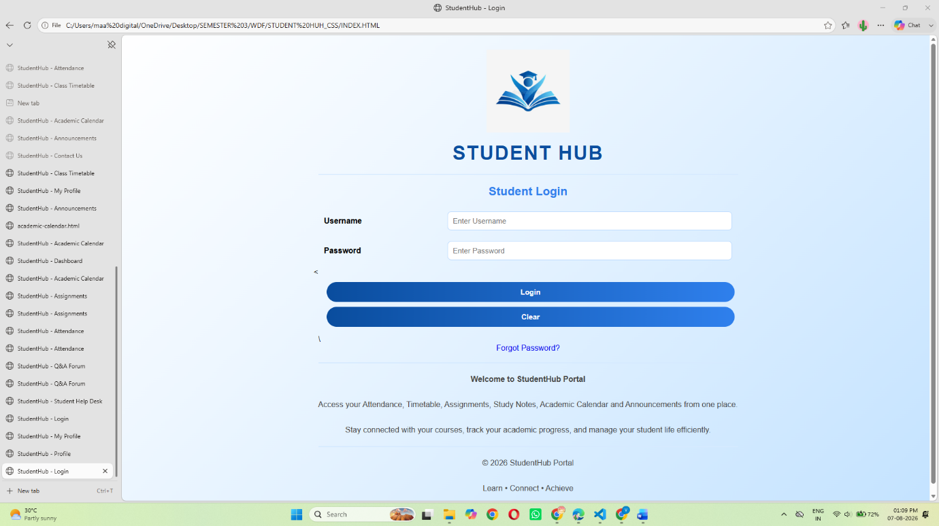

STUDENT DASHBOARD

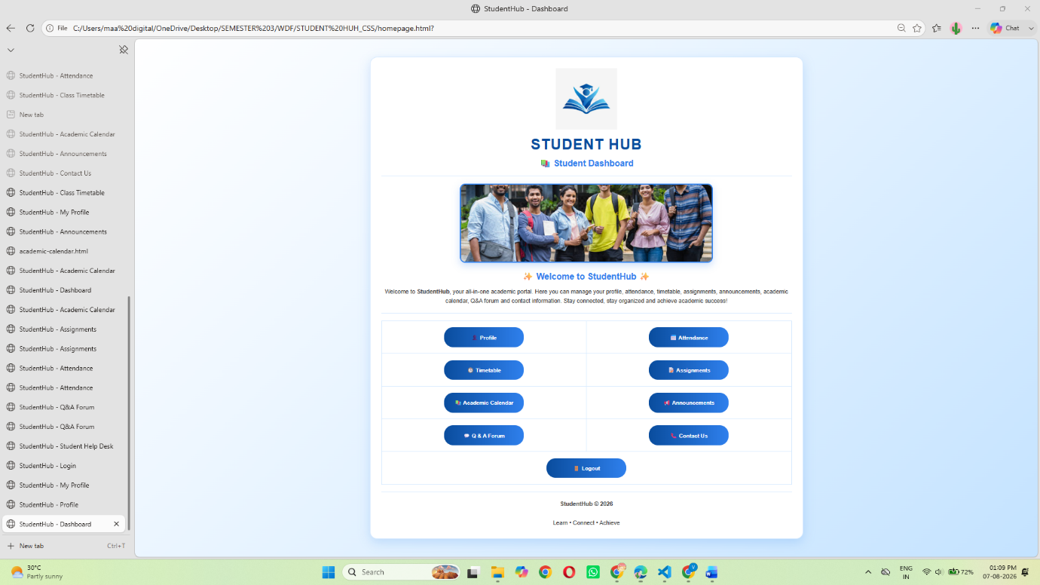

STUDENT PROFILE PAGE
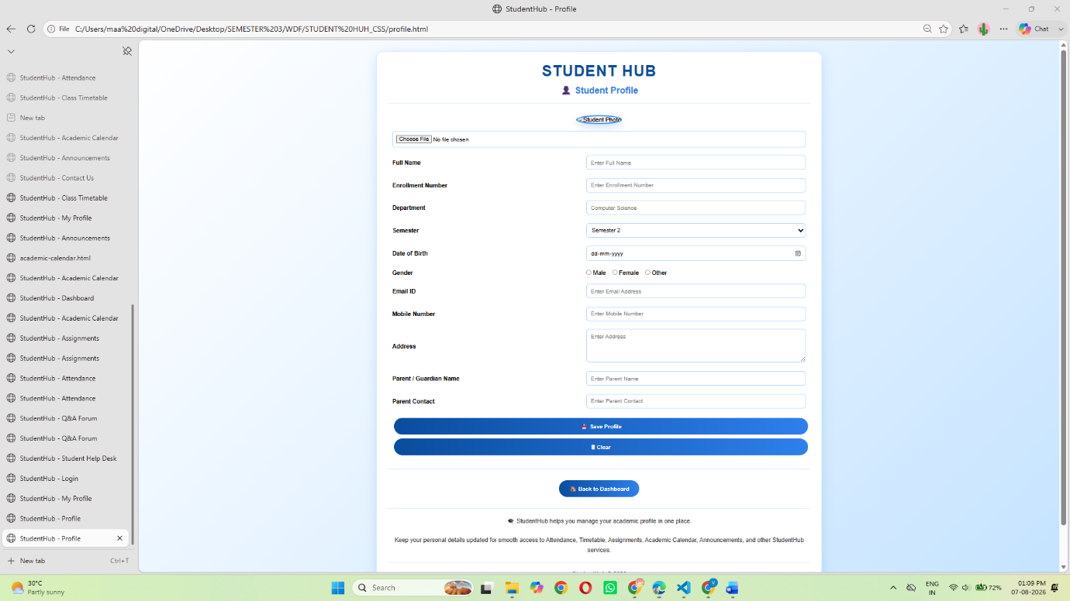

STUDENT ATTENDANCE REPORT PAGE

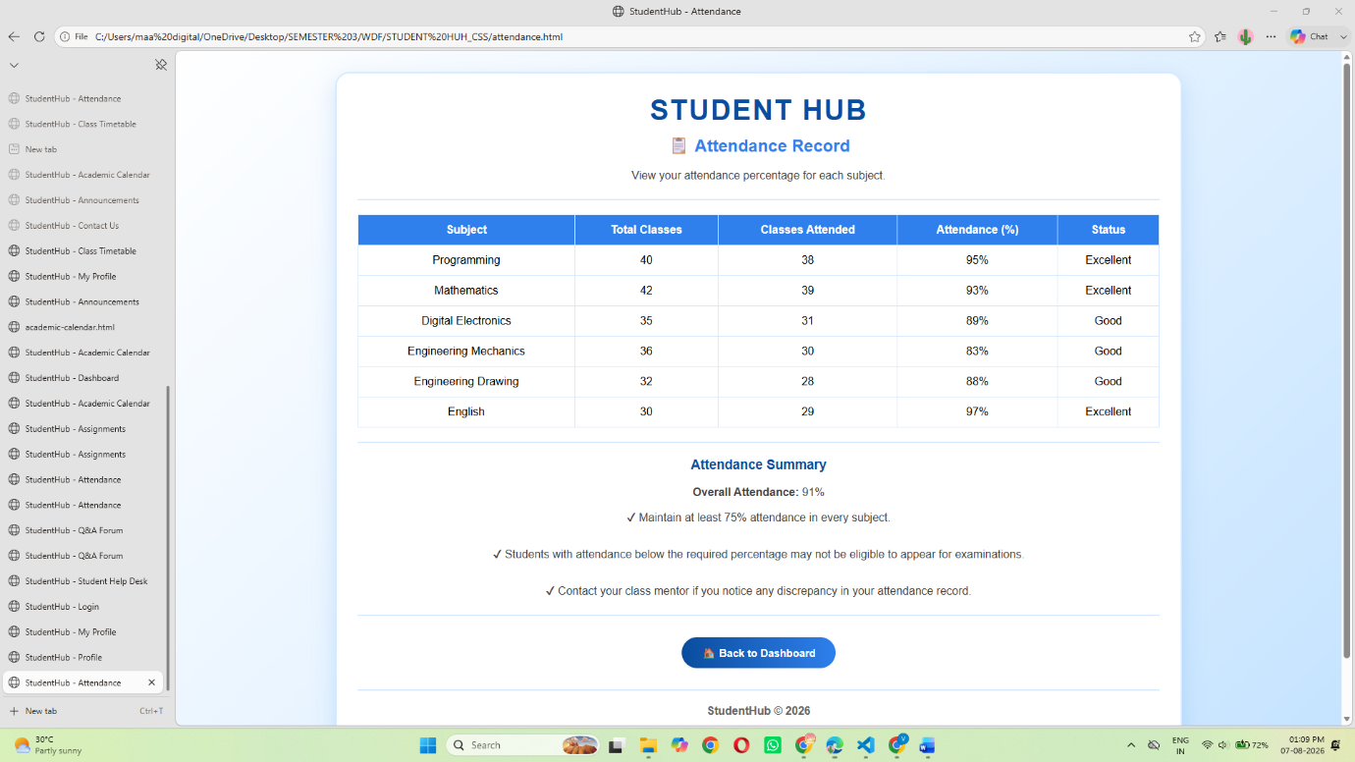

STUDENT WEEKLY TIMETABLE REPORT PAGE
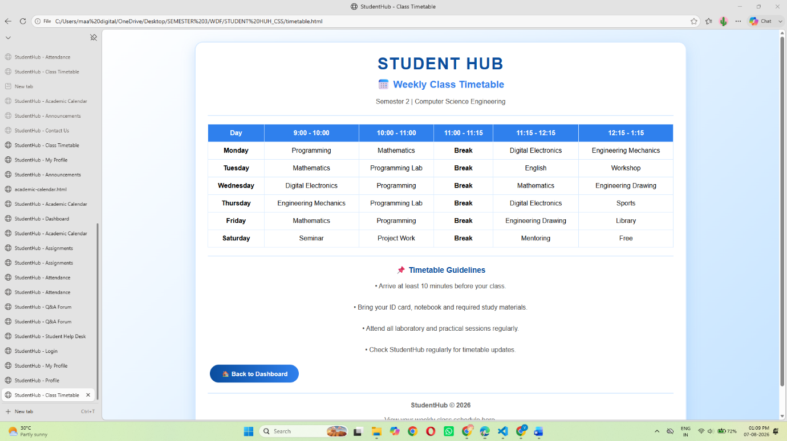
STUDENTS ASSIGMENT PAGE

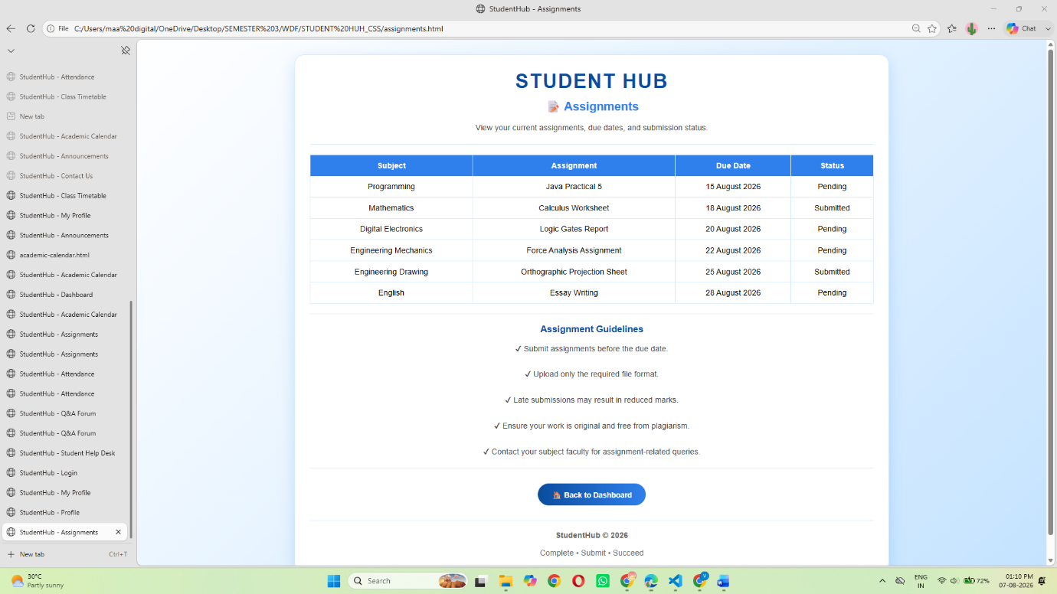

STUDENT ACADEMIC CALENDAR 2026 PAGE
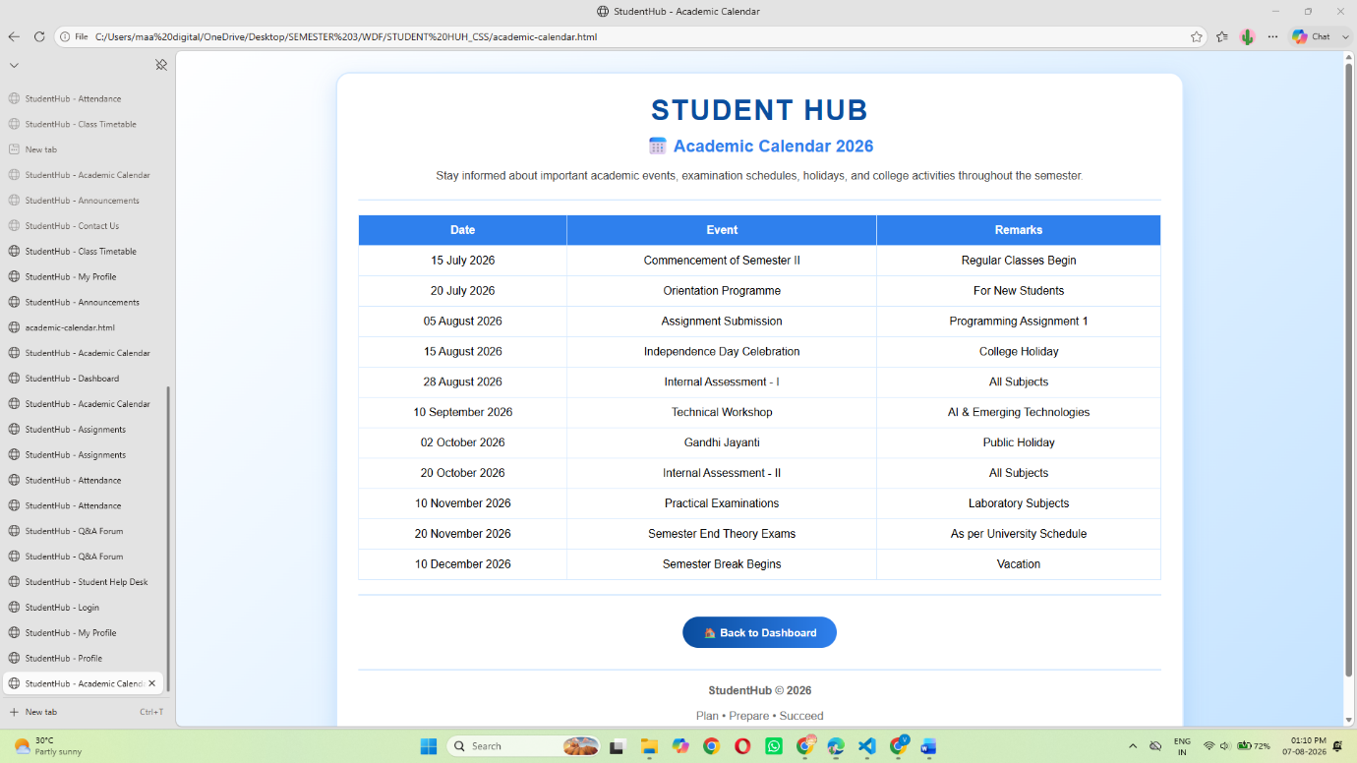

STUDENT COLLEGE ANNOUCEMENTS PAGE
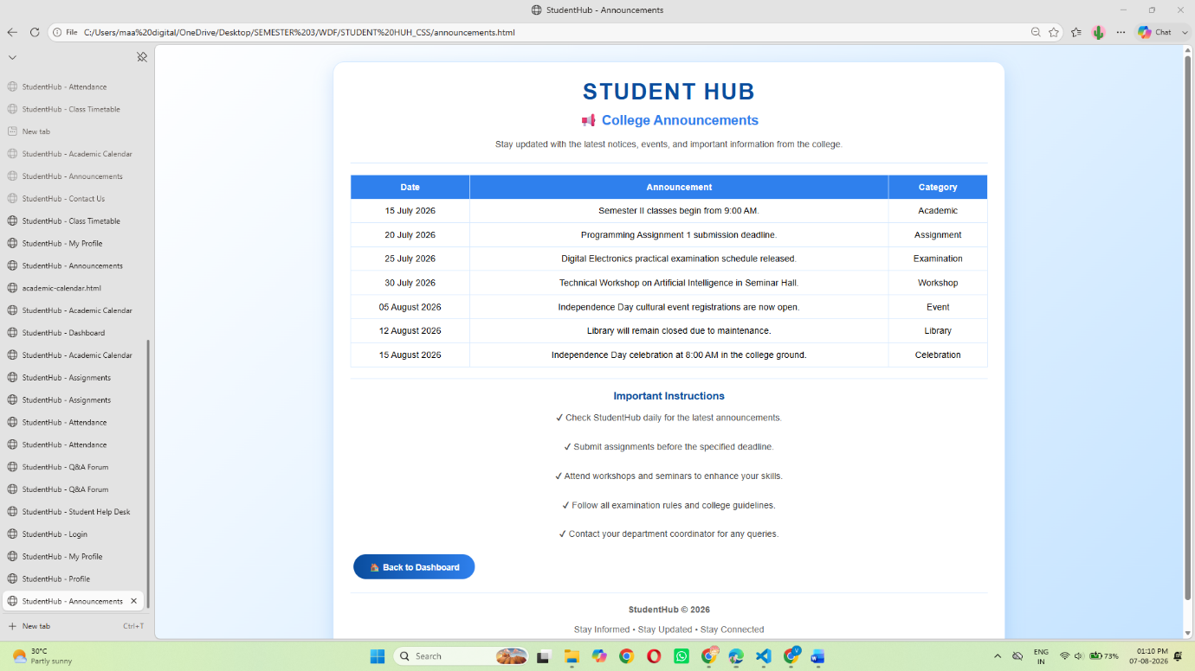

STUDENT HELP DESK(QNA FORUM) PAGE
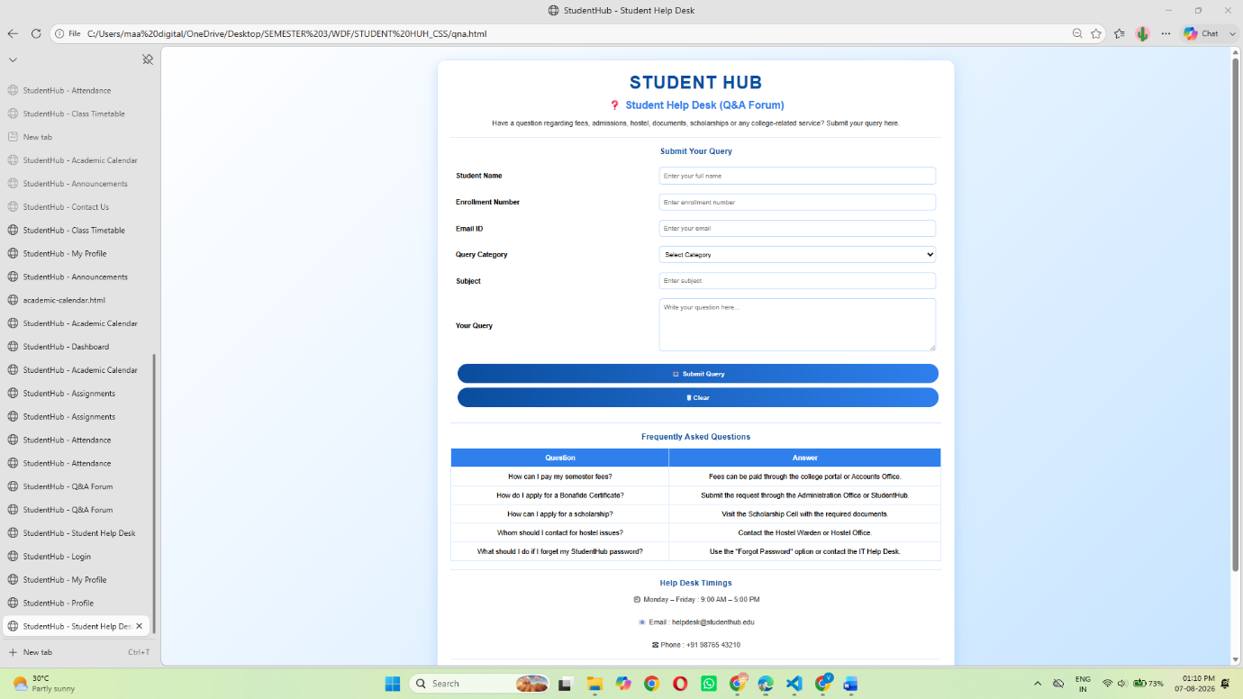

STUDENT CONTACT US PAGE

